Use-case Diagram
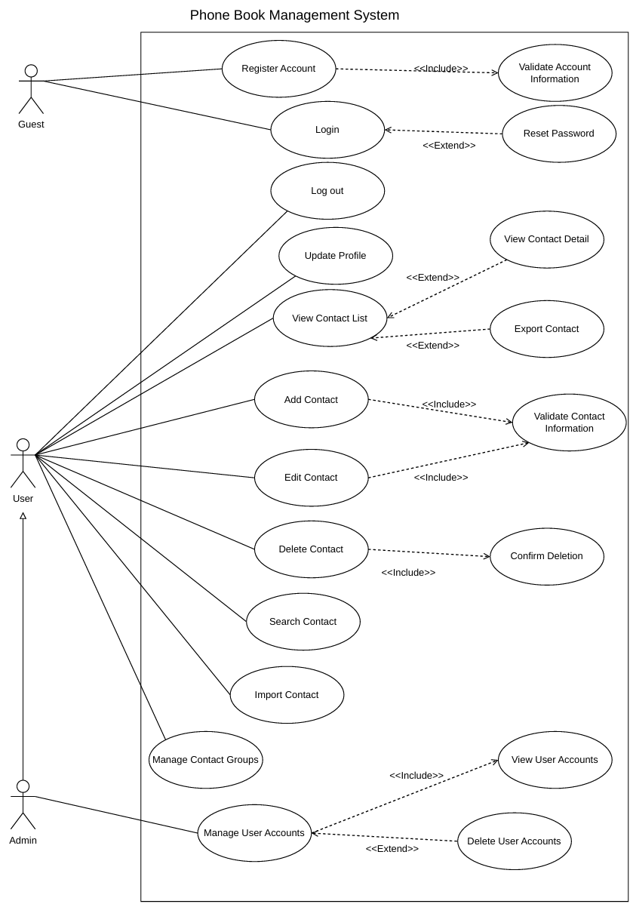
- Overview diagram

  - List of Actors
SN | Actor | Meaning
1 | Admin | The person who control system
2 | User | Member, a user who already has an account and has logged into the system.
3 | Guest | Guests, users who haven't logged into the system

  - List of Use-case
SN | Use-case | Meaning | Note
1 | Register Account | Allows new users to create an account by providing the required registration information.
2 | Validate Account Information | Checks whether the provided account information is complete, valid, and meets the system's requirements.
3 | Login | Allows registered users to access the system by entering their username/email and password.
4 | Reset Password | A user shall be able to securely reset their forgotten password to regain account access.
5 | Log Out | Allows users to securely exit their current account and end their session.
6 | Update Profile | Allows users to view and modify their personal account information.
7 | View Contact List | Displays the list of contacts saved in the user's account.
8 | View Contact Detail | Allows users to view detailed information about a selected contact.
9 | Export Contact | A user shall be able to export their contact list to an external file for backup purposes.
10 | Add Contact | Allows users to create and save a new contact with information such as name, phone number, email, and address.
11 | Edit Contact | Allows users to modify the information of an existing contact.
12 | Validate Contact Information | Checks whether the contact information is complete and valid before saving it to the system.
13 | Delete Contact | Registered users shall have the ability to permanently remove contacts from their address book.
14 | Confirm Deletion | A confirmation dialog shall prompt the user before any contact is permanently deleted.
15 | Search Contact | The application shall provide a search function to find specific contacts using keywords.
16 | Import Contact | A user shall be able to import multiple contacts simultaneously from a supported external file.
17 | Manage Contact Groups | Users shall be able to create, rename, and delete custom groups to organize their contacts.
18 | Manage User Accounts | An administrator shall possess the authority to oversee and manage all system user profiles.
19 | View User Accounts | The administrative dashboard shall display a complete list of registered user accounts.
20 | Delete User Accounts | An administrator shall be capable of deleting or deactivating any existing user account.

- Use Case: Register Account
  - Summary
Allows a visitor to create a new account in order to use the system's contact-management features.
Actor: Guest
  - Flow of Events
    - Main Flow
- Use case starts when the Guest selects the account registration function.
- The system displays a registration form and requests the required account information.
- The Guest enters the information and submits the registration request.
- The system invokes Validate Account Information to validate the submitted data.
- If the information is valid, the system creates the new account and displays a success message.
    - Alternative Flows
If information is missing or invalid, or the account cannot be created, the system displays an error and allows the Guest to correct the information or cancel registration.
  - Special Requirements
Account information must be validated before it is stored.
Authentication information must be protected during transmission and storage.
  - Pre-conditions
The Guest is not logged in and is accessing the system.
  - Post-conditions
If successful, the new account is stored in the system. If registration fails, no account data is created or changed.
  - Extension Points
None.

- Use Case: Validate Account Information
  - Summary
Validates the completeness and correctness of the information provided by a Guest during registration.
Actor: Register Account (included use case)
  - Flow of Events
    - Main Flow
- Use case is invoked when the Guest submits the registration form in Register Account.
- The system receives the registration data.
- The system checks required fields and data formats according to the system's rules.
- The system checks the consistency and validity of the account information.
- The system returns the validation result to Register Account.
    - Alternative Flows
If required data is missing or incorrectly formatted, the system returns the corresponding errors for correction.
If the account identifier has already been used, the system informs the Guest that different information is required.
  - Special Requirements
Validation must be performed by the server and must not rely solely on client-side checks.
  - Pre-conditions
Register Account is in progress and the system has received the registration data.
  - Post-conditions
The validation result is returned to Register Account. This use case does not create an account by itself.
  - Extension Points
None.

- Use Case: Login
  - Summary
Allows a Guest to authenticate and access functions available to an authorized User.
Actor: Guest
  - Flow of Events
    - Main Flow
- Use case starts when the Guest selects Login.
- The system displays the login form.
- The Guest enters login credentials and submits the request.
- The system verifies the submitted credentials against the stored account information.
- If the credentials are correct and the account is allowed to log in, the system creates an authenticated session and grants access.
    - Alternative Flows
If the credentials are incorrect, the system displays an error and allows the Guest to try again or cancel.
If the account is not permitted to log in, the system displays an appropriate message and does not create a session.
  - Special Requirements
Credentials must be transmitted and processed securely.
The login session must be managed to prevent unauthorized access.
  - Pre-conditions
The Guest is not logged in and has an account registered in the system.
  - Post-conditions
If successful, the user becomes authenticated with the appropriate role. Otherwise, the system remains unchanged.
  - Extension Points
Reset Password: extends Login when the user needs to recover a forgotten password.
- Use Case: Reset Password
  - Summary
Allows a user who cannot log in to recover or reset their password.
Actor: Guest
  - Flow of Events
    - Main Flow
Use case starts when the Guest selects Reset Password from the Login function.
The system asks the user to provide an account identifier, such as an email address or username, depending on the system configuration.
The user enters the information and submits the recovery request.
The system checks whether the corresponding account exists.
The system performs the password-reset procedure using the implemented security mechanism and informs the user of the result.
    - Alternative Flows
If the account cannot be found, the system displays a message and allows the user to retry or exit.
If the recovery process fails, the system displays an error and leaves the current password unchanged.
  - Special Requirements
The recovery process must verify ownership of the account.
A new password or password-reset link must be handled securely.
  - Pre-conditions
The user is not logged in and is using Login or the password-recovery screen.
  - Post-conditions
If successful, the account credentials are updated through the recovery process. Otherwise, the current password remains unchanged.
  - Extension Points
This use case extends Login.

- Use Case: Log out
  - Summary
Allows an authenticated User to end the current session and sign out of the account.
Actor: User
  - Flow of Events
    - Main Flow
- Use case starts when the User selects Log out.
- The system receives the logout request.
- The system terminates or invalidates the current login session.
- The system changes the user's state to logged out and displays the appropriate screen.
    - Alternative Flows
If the session has already expired or no longer exists, the system still returns the user to the logged-out state.
  - Special Requirements
The login session must be invalidated after logout.
  - Pre-conditions
The User is logged in to the system.
  - Post-conditions
The current session has ended. The user can no longer access functions requiring authentication until logging in again.
  - Extension Points
None.
- Use Case: Update Profile
  - Summary
Allows a User to view and update their personal profile information.
Actor: User
  - Flow of Events
    - Main Flow
- Use case starts when the User selects Update Profile.
- The system displays the User's current profile information.
- The User edits the information they want to change.
- The User submits the update request.
- The system validates the submitted data.
- If the data is valid, the system saves the changes and displays the result.
    - Alternative Flows
If information is missing or invalid, the system displays an error and asks the User to correct it.
If the User cancels the operation, the system does not save the changes.
  - Special Requirements
Only an authenticated User may update their own profile.
Personal information must be protected and displayed according to access permissions.
  - Pre-conditions
The User is logged in to the system.
  - Post-conditions
If successful, the profile is updated. If the operation fails or is cancelled, the existing profile remains unchanged.
  - Extension Points
None.

- Use Case: View Contact List
  - Summary
Allows a User to view the contacts in the address book that they are authorized to manage.
Actor: User
  - Flow of Events
    - Main Flow
- Use case starts when the User selects the contact-list function.
- The system identifies the currently logged-in User.
- The system retrieves the contacts within that User's authorized scope.
- The system displays the contact list with summary information.
- The User may select a contact to view its details or choose to export contacts.
    - Alternative Flows
If the address book contains no contacts, the system displays an empty list and may suggest adding a contact.
If the data cannot be loaded, the system displays an error and allows the User to retry.
  - Special Requirements
A User may only view contacts they are authorized to access.
The list should be displayed appropriately when it contains many contacts.
  - Pre-conditions
The User is logged in.
  - Post-conditions
The contact list is displayed. The contact data is not changed.
  - Extension Points
View Contact Detail: when the User selects a contact in the list. Export Contact: when the User requests to export contact data.

- Use Case: View Contact Detail
  - Summary
Allows a User to view the complete information of a selected contact.
Actor: User
  - Flow of Events
    - Main Flow
- Use case starts when the User selects a contact from View Contact List.
- The system receives the identifier of the selected contact.
- The system checks that the contact exists and that the User is authorized to view it.
- The system retrieves and displays the contact's detailed information.
    - Alternative Flows
If the contact does not exist or the User is not authorized to view it, the system displays a message and returns to the contact list.
  - Special Requirements
The system must not disclose contact information outside the User's authorized scope.
  - Pre-conditions
The User is logged in and viewing View Contact List; a contact has been selected.
  - Post-conditions
The contact details are displayed. No contact data is changed.
  - Extension Points
This use case extends View Contact List.

- Use Case: Export Contact
  - Summary
Allows a User to export contact information or the address book to a file for external use or backup.
Actor: User
  - Flow of Events
    - Main Flow
- Use case starts when the User selects Export Contact from the contact-list screen.
- The system determines which contacts should be exported based on the User's selection or the current list.
- The system checks the User's access permissions for the requested data.
- The system collects the data and generates an export file in a supported format.
- The system makes the file available for download and displays the result.
    - Alternative Flows
If there is no matching data, the system informs the User that there are no contacts to export.
If file generation fails, the system displays an error and allows the User to retry.
  - Special Requirements
The export file must contain only data the User is authorized to access.
The supported file format is determined by the implementation.
  - Pre-conditions
The User is logged in and is viewing View Contact List.
  - Post-conditions
If successful, an export file is generated. The contact data stored in the system is not changed.
  - Extension Points
This use case extends View Contact List.

- Use Case: Add Contact
  - Summary
Allows a User to add a new contact to their personal address book.
Actor: User
  - Flow of Events
    - Main Flow
- Use case starts when the User selects Add Contact.
- The system displays the add-contact form.
- The User enters the contact information and submits the save request.
- The system invokes Validate Contact Information to validate the data.
- If the information is valid, the system saves the new contact to the User's address book.
- The system displays the result of the operation.
    - Alternative Flows
If the information is invalid, the system displays errors and asks the User to correct them.
If the User cancels the operation, the system does not create a new contact.
  - Special Requirements
Contact information must be validated before it is stored.
The new contact must be associated with the correct User account.
  - Pre-conditions
The User is logged in and has permission to manage an address book.
  - Post-conditions
If successful, the new contact appears in the User's address book. If the operation fails, the address book remains unchanged.
  - Extension Points
This use case includes Validate Contact Information.

- Use Case: Edit Contact
  - Summary
Allows a User to edit the information of an existing contact in their address book.
Actor: User
  - Flow of Events
    - Main Flow
- Use case starts when the User selects a contact and requests to edit it.
- The system identifies the selected contact and checks the User's permission to edit it.
- The system displays the contact's current information.
- The User edits the required fields and submits the update request.
- The system invokes Validate Contact Information to validate the updated data.
- If the data is valid, the system updates the contact and displays the result.
    - Alternative Flows
If the contact does not exist or the User is not authorized to edit it, the system displays an error and makes no changes.
If the data is invalid, the system displays errors and asks the User to correct them.
If the User cancels the operation, the system keeps the existing contact information.
  - Special Requirements
Only the owner or an appropriately authorized user may edit a contact.
  - Pre-conditions
The User is logged in. The contact exists and is within the User's authorized scope.
  - Post-conditions
If successful, the contact information is updated. If the operation fails or is cancelled, the old data is retained.
  - Extension Points
This use case includes Validate Contact Information.

- Use Case: Validate Contact Information
  - Summary
Validates contact information before a new contact is added or an existing contact is updated.
Actor: Add Contact and Edit Contact (included use case)
  - Flow of Events
    - Main Flow
- Use case is invoked when Add Contact or Edit Contact submits data to be saved.
- The system receives the contact information.
- The system checks required fields and data formats, where applicable.
- The system checks the validity and consistency of the entered values.
- The system returns the validation result to the calling use case.
    - Alternative Flows
If any field is missing or incorrectly formatted, the system returns the relevant errors for the User to correct.
  - Special Requirements
The validation rules must be consistent for both adding and editing contacts.
  - Pre-conditions
Add Contact or Edit Contact is in progress and input data has been provided.
  - Post-conditions
The validation result is returned. This use case does not independently add or update a contact.
  - Extension Points
None.
- Use Case: Delete Contact
  - Summary
Allows a User to delete a contact from their personal address book.
Actor: User
  - Flow of Events
    - Main Flow
- Use case starts when the User selects a contact and requests deletion.
- The system identifies the contact to be deleted.
- The system invokes Confirm Deletion to ask the User for confirmation.
- If the User confirms, the system checks deletion permissions and deletes the contact.
- The system displays the deletion result and refreshes the contact list.
    - Alternative Flows
If the User does not confirm, the system cancels the operation and retains the contact.
If the contact does not exist or the User is not authorized to delete it, the system displays an error and makes no changes.
  - Special Requirements
Deletion must be subject to access checks to prevent users from deleting another user's data.
  - Pre-conditions
The User is logged in. The contact exists in an address book the User is authorized to manage.
  - Post-conditions
If successful, the contact is deleted from the address book. If cancelled or unsuccessful, the data remains unchanged.
  - Extension Points
This use case includes Confirm Deletion.

- Use Case: Confirm Deletion
  - Summary
Asks the User to confirm before the system performs a contact-deletion operation.
Actor: User (included by Delete Contact)
  - Flow of Events
    - Main Flow
- Use case is invoked by Delete Contact before the data is deleted.
- The system displays the contact's identifying information and a deletion-confirmation message.
- The User chooses to confirm or cancel the operation.
- The system returns the confirmation result to Delete Contact.
    - Alternative Flows
If the User cancels or closes the confirmation dialog, the system returns a negative confirmation result and the contact is not deleted.
  - Special Requirements
The confirmation message should clearly identify the item to be deleted to reduce accidental deletion.
  - Pre-conditions
Delete Contact is in progress and the contact to be deleted has been identified.
  - Post-conditions
The confirmation or cancellation result is returned to Delete Contact. This use case does not delete data itself.
  - Extension Points
None.

- Use Case: Search Contact
  - Summary
Allows a User to search their address book using information or keywords they provide.
Actor: User
  - Flow of Events
    - Main Flow
- Use case starts when the User selects Search Contact.
- The system displays a search field or search form.
- The User enters search keywords or criteria and submits the request.
- The system searches within the address book the User is authorized to access.
- The system displays the contacts matching the search criteria.
    - Alternative Flows
If no matching contacts are found, the system informs the User that there are no results.
If the search criteria are invalid or an error occurs, the system displays a message and allows the User to revise the criteria or retry.
  - Special Requirements
Search results must be limited to data the User is authorized to access.
  - Pre-conditions
The User is logged in and has permission to view the address book.
  - Post-conditions
Search results are displayed. Contact data is not changed.
  - Extension Points
None.

- Use Case: Import Contact
  - Summary
Allows a User to import a list of contacts from an external file into their address book.
Actor: User
  - Flow of Events
    - Main Flow
- Use case starts when the User selects Import Contact.
- The system displays the file-selection function.
- The User selects and uploads a file containing contact data.
- The system checks the file type, format, and readability.
- The system reads the contact records and validates the data before import.
- The system adds valid contacts to the User's address book and displays the import result.
    - Alternative Flows
If the file format is unsupported, unreadable, or contains no data, the system displays an error and asks the User to select another file.
If some records are invalid, the system reports the rejected records; valid records are processed according to the system's import policy.
If the User cancels before confirming the import, the system does not import the data.
  - Special Requirements
The system must validate file data before writing it to the database.
Allowed upload file types must be restricted and checked according to the implementation's security policy.
  - Pre-conditions
The User is logged in and has permission to add contacts.
  - Post-conditions
If successful, valid contacts are imported into the User's address book. Existing data is not changed except as explicitly reported by the import operation.
  - Extension Points
None.

- Use Case: Manage Contact Groups
  - Summary
Allows a User to organize contacts into groups for easier address-book management.
Actor: User
  - Flow of Events
    - Main Flow
- Use case starts when the User selects Manage Contact Groups.
- The system displays the User's existing contact groups.
- The User selects an available group-management operation, such as creating, renaming, or deleting a group, or managing group membership.
- The system displays the relevant form or group information.
- The User enters or edits information, or confirms the selected operation.
- The system validates the data and permissions, then saves the changes.
- The system displays the result and refreshes the group list.
    - Alternative Flows
If group data is invalid, the system displays an error and asks the User to correct it.
If the User cancels, the system does not save the changes.
If the group does not exist or is outside the User's authorized scope, the system displays an error and rejects the operation.
  - Special Requirements
Each group and its contact memberships must belong to the User's authorized scope.
Group-management operations must not expose another user's address-book data.
  - Pre-conditions
The User is logged in.
  - Post-conditions
If successful, group information or contact-to-group relationships are updated. If the operation fails or is cancelled, the previous state is retained.
  - Extension Points
None.

- Use Case: Manage User Accounts
  - Summary
Allows an Admin to manage user accounts in the system.
Actor: Admin
  - Flow of Events
    - Main Flow
- Use case starts when the Admin selects Manage User Accounts.
- The system verifies the Admin's administrative permissions.
- The system displays the user-account management interface.
- The Admin selects an appropriate account-management operation.
- The system performs the selected function and displays the result.
    - Alternative Flows
If the visitor does not have Admin privileges, the system denies access and does not display administrative data.
If a management operation fails, the system displays an error and retains any data that was not successfully updated.
  - Special Requirements
Only an authorized Admin may access this function.
User-account information must be protected and administrative operations must be controlled.
  - Pre-conditions
The Admin is logged in with an account that has administrative privileges.
  - Post-conditions
Depending on the operation, account data may be viewed or changed. If no operation succeeds, the data remains unchanged.
  - Extension Points
View User Accounts is included in Manage User Accounts. Delete User Accounts extends Manage User Accounts.

- Use Case: View User Accounts
  - Summary
Allows an Admin to view the list of user accounts in the system.
Actor: Admin (included by Manage User Accounts)
  - Flow of Events
    - Main Flow
- Use case is invoked when the Admin accesses Manage User Accounts.
- The system verifies the Admin's administrative privileges.
- The system retrieves the list of user accounts.
- The system displays the account list with the summary information permitted for administration.
- The Admin may select an account or continue with another management operation.
    - Alternative Flows
If there are no user accounts, the system displays an empty list.
If the list cannot be loaded, the system displays an error and allows the Admin to retry.
  - Special Requirements
Only information necessary for administration should be displayed. Sensitive information such as passwords must not be displayed.
  - Pre-conditions
The Admin is logged in and is using Manage User Accounts.
  - Post-conditions
The user-account list is displayed. Account data is not changed.
  - Extension Points
None.

- Use Case: Delete User Accounts
  - Summary
Allows an Admin to delete a selected user account from the system.
Actor: Admin
  - Flow of Events
    - Main Flow
- Use case starts when the Admin selects the account-deletion operation in Manage User Accounts.
- The system identifies the account selected by the Admin.
- The system displays the account information and asks the Admin to confirm the deletion.
- The Admin confirms the deletion.
- The system checks the Admin's permission and the conditions for deleting the account.
- If the request is valid, the system deletes or deactivates the account according to system policy and displays the result.
    - Alternative Flows
If the Admin cancels the confirmation, the system does not delete the account.
If the account does not exist or does not meet the deletion conditions, the system displays an error and retains the account data.
  - Special Requirements
Only an Admin with the appropriate privileges may delete accounts.
The integrity of data associated with the account must be considered before deletion.
  - Pre-conditions
The Admin is logged in and is using Manage User Accounts. The target account exists.
  - Post-conditions
If successful, the account is deleted or deactivated according to the implementation policy. If cancelled or unsuccessful, the account state remains unchanged.
  - Extension Points
This use case extends Manage User Accounts.

Data Flow Diagram

